Secure Message Encryption and Cryptanalysis Using Hill Cipher with Key Sensitivity Analysis
Project Report
On
Computer Networking: Security
(CSE3752)


Submitted by:
Name: Amit Kumar Regd. No.: 2341011129
Name: Bipul Mohapatra Regd. No.: 2341013361
Name: Khushboo Priya Regd. No.: 2341016441
Name: Subham Sahu Regd. No.: 2341019261

B. Tech. CSE(CORE) 6th Semester (Section 2K1)

INSTITUTE OF TECHNICAL EDUCATION AND RESEARCH (FACULTY OF ENGINEERING)
SIKSHA ‘O’ ANUSANDHAN (DEEMED TO BE UNIVERSITY),
BHUBANESWAR, ODISHA

Declaration
We, the undersigned students of B. Tech. of CSE-CORE Department hereby declare that we own the full responsibility for the information, results etc. provided in this PROJECT titled Secure Message Encryption and Cryptanalysis using Hill Cipher with Key Sensitivity Analysis submitted to Siksha ‘O’ Anusandhan (Deemed to be University), Bhubaneswar for the partial fulfillment of the subject Computer Networking: Security (CSE 3752). We have taken care in all respect to honor the intellectual property right and have acknowledged the contribution of others for using them in academic purpose and further declare that in case of any violation of intellectual property right or copyright we, as the candidate(s), will be fully responsible for the same.

Name: Amit Kumar Regd. No.: 2341011129

Name: Bipul Mohapatra Regd. No.: 2341013361

Name: Khushboo Priya Regd. No.: 2341016441

Name: Subham Sahu Regd. No.: 2341019261

Date: /05/2026

Place: ITER, SOA, Bhubaneswar

Abstract

This project presents the design and implementation of a secure message encryption system using the Hill Cipher technique. The Hill Cipher is a classical cryptographic algorithm that uses matrix multiplication and modular arithmetic to encrypt and decrypt messages. The project was developed to understand both the working principles of encryption and the weaknesses that can be exploited through cryptanalysis.
The implementation includes encryption and decryption using 2×2 and 3×3 key matrices, key matrix validation, sensitivity analysis, performance analysis, and a known-plaintext attack module. Python and NumPy were used for performing matrix operations and modular calculations efficiently. The results obtained from the project show that small changes in the key or plaintext produce major differences in the ciphertext, improving diffusion within the encryption process.
At the same time, the project demonstrates that Hill Cipher is vulnerable to key recovery attacks when plaintext and ciphertext pairs are known. This highlights the limitations of classical cryptography and explains why modern algorithms such as AES are preferred in current communication systems. Overall, the project provides practical exposure to encryption, decryption, and cryptanalysis concepts in cybersecurity.

Contents

Serial No. | Chapter No. | Title of the Chapter | Page No.
1. | 1 | Introduction | 1
2. | 2 | Problem Statement | 2
3. | 3 | Methodology | 3
4. | 4 | Implementation | 5
5. | 5 | Results and interpretation | 14
6. | 6 | Conclusion | 19
7. |  | References

- Introduction
In modern digital communication, data encryption is critical for ensuring user privacy, confidentiality and the integrity of data against any unauthorized access or tampering.
Cryptography is the study of encryption techniques, and cryptanalysis is defined as the practice of breaking the codes without any prior knowledge of the key. The combination of both these studies forms the basis for cryptology. This is done using encryption algorithms that mathematically convert the plaintext into an unreadable format which is referred to as ciphertext. Traditionally there are two approaches to encrypting data that are substitution and transposition. However, advancements in technology and improved computation have successfully enhanced cryptanalysis techniques. Hence modern-day encryption techniques like DES (Data Encryption Standard) and AES (Advanced Encryption Standard) use a combination of both to make cryptanalysis harder and improve resistance against attacks.
Invented by Lester S. Hill in 1929, Hill cipher is a polygraphic substitution technique which is based on linear algebra. In this approach, each letter is represented by a number modulo 26 to encrypt the plaintext.

Encryption in Hill Cipher:
  - Divide the plaintext into blocks of n letters.
  - Treat each block as an n-dimensional vector.
  - Multiply this vector by an invertible n × n key matrix.
  - Take the result modulo 26.
  - The final values form the ciphertext.
Decryption in Hill Cipher:
  - Find the inverse of the key matrix (mod 26).
  - Divide the ciphertext into blocks of n letters.
  - Treat each block as an n-dimensional vector.
  - Multiply each vector by the inverse key matrix.
  - Take the result modulo 26.
  - Convert the numbers back to letters to obtain the original plaintext.
The Hill cipher introduces diffusion which hides the relationship between ciphertext and the plaintext and hence takes a step beyond simple traditional techniques like Caesar cipher, Vigenère cipher etc. and increases the complexity of encryption providing better security and resistance against cryptanalysis. However, it is dependent on a linear transformation which makes it easier for attackers to predict the key. This makes Hill cipher unfavorable and insecure in terms of the modern-day security standards. Although it is no longer used in modern communication systems it still proves to be a foundational approach towards learning and understanding the practical implementations of encryption techniques.

Problem Statement
- Problem Statement and Objects of Implementation

In today's digital world, the ability to communicate securely is very important to protect data from unauthorized access. We use many encryption techniques to convert readable information into an unreadable form so only the users that are authorized can access it. Hence understanding how encryption systems work and how they can be bypassed is essential in fields such as Cybersecurity.

The Hill Cipher is a classical encryption technique that relies on matrix multiplication and modular arithmetic. Even though it provides better security as compared to substitution ciphers, it has many weaknesses due to its mathematical structure being too linear. It is vulnerable to attacks such as the known plaintext attacks, where the key that is used for encryption can be recovered using the plaintext and ciphertext pairs.

Most of the simpler implementations of the Hill Cipher primarily focus on encryption and decryption without analyzing its weaknesses and limitations in security. Hence the goal of this project is to implement the Hill Cipher technique and study its vulnerabilities through methods such as:

Encryption and decryption using 2×2 and 3×3 matrices Key matrix validation
Key and plaintext sensitivity analysis Known-plaintext cryptanalysis Performance analysis

In order to better understand the strengths and limitations of classical encryption techniques.
- Constraints

The project works only with English alphabets. Only 2×2 and 3×3 matrices are used.
The key matrix must be invertible for proper decryption.
Padding is added if the plaintext length is incomplete. The Hill Cipher is vulnerable to known-plaintext attacks.
The project is made only for learning and analysis purposes.
The Hill Cipher is not secure enough for modern communication systems.

Methodology

Hill cipher Encryption process:
Block formation:
Split numbers into blocks of size n (where n=2 or 3)
For 2x2 matrix n=2 For 3x3 matrix n=3

Numerical Conversion
(A-0, Z-25) mod 26

Key matrix 2x2 or 3x3

Matrix Multiplication: C=K*P (mod 26)

Text Processing: Convert to uppercase
Remove spaces & symbols Add padding X if needed

PLAINTEXT (ex: HELLO)

Ciphertext (ex: GYBNQK)

Numerical to text (Convert the numbers back to letters)

Hill cipher Decryption process:
Inverse Key matrix (k^-1) mod 26
2x2 or 3x3

Matrix Multiplication: P=(K^-1)*C (mod 26)

Numerical to text (Convert the numbers back to letters)

Ciphertext (ex: GYBNQK)
Text Processing: Convert to uppercase Remove spaces & symbols

Numerical Conversion
(A-0, Z-25) mod 26

Block formation:
Split numbers into blocks of size n (where n=2 or 3)

Plaintext (HELLOX)

Here it is necessary that key matrix must be invertible which means that GCD(determinant of key matrix, 26) must be equal to 1.

Pseudocodes:
Hill cipher Encryption Algorithm:
START
Input plaintext
Select key matrix (2x2 or 3x3)
Check whether key matrix is invertible If invalid:
Display error Stop
Convert plaintext to uppercase Remove spaces and symbols Add padding 'X' if needed
Convert plaintext letters to numbers Split plaintext into blocks
For each block:
Multiply key matrix with plaintext block Apply modulo 26
Convert result to ciphertext letters Display ciphertext
END

Hill cipher Decryption Algorithm:
START
Input ciphertext Select key matrix
Find inverse of key matrix modulo 26 If inverse does not exist:
Display error Stop
Convert ciphertext letters to numbers Split ciphertext into blocks
For each block:
Multiply inverse matrix with ciphertext block Apply modulo 26
Convert result to plaintext letters Display plaintext
END
Known plaintext attack algorithm
START
Input plaintext matrix P Input ciphertext matrix C
Find inverse of plaintext matrix: P⁻¹ mod 26
Recover key matrix: K = C × P⁻¹ mod 26
Display recovered key matrix END
Tools used for implementation of algorithm/pseudocode:
- Python
- Numpy library
- Time module
- Math module
- IDLE (Python editor)

Implementation
import numpy as np import time
from math import gcd MOD = 26
# TEXT CONVERSION FUNCTIONS
def text_to_numbers(text): text = ''.join(
char for char in text.upper() if char.isalpha()
)
return [
ord(char) - ord('A') for char in text
]
def numbers_to_text(numbers): return ''.join(
chr(int(num) % 26 + ord('A')) for num in numbers
)
def prepare_text(text, block_size): text = ''.join(
char for char in text.upper() if char.isalpha()
)
while len(text) % block_size != 0: text += 'X'
return text
# MODULAR INVERSE
def mod_inverse(a, m): a = int(a % m)
for x in range(1, m):
if (a * x) % m == 1: return x
return None
def matrix_determinant(matrix):
det = round(np.linalg.det(matrix)) return int(det)
def is_valid_key(matrix):
det = matrix_determinant(matrix) det = det % MOD
return gcd(det, MOD) == 1 def matrix_inverse(matrix):
det = matrix_determinant(matrix) det_mod = det % MOD
det_inverse = mod_inverse(det_mod, MOD) if det_inverse is None:
return None
matrix = np.array(matrix) adjoint = np.round(
det * np.linalg.inv(matrix)
).astype(int) inverse_matrix = (
det_inverse * adjoint

) % MOD
return inverse_matrix # DISPLAY MATRIX
def print_matrix(matrix): for row in matrix:
print(row)
# SELECT MATRIX TYPE
def choose_key_matrix(): print("\nSelect Key Matrix Type") print("1. 2x2 Matrix")
print("2. 3x3 Matrix")
choice = input("\nEnter Choice: ") # 2x2 MATRIX
if choice == '1': key_matrix = np.array([
[3, 3],
[2, 5]
])
# 3x3 MATRIX
elif choice == '2': key_matrix = np.array([
[6, 24, 1],
[13, 16, 10],
[20, 17, 15]
])
else:
print("\nInvalid Choice!") return None
return key_matrix # ENCRYPTION
def encrypt(plaintext, key_matrix): if not is_valid_key(key_matrix): print("\nInvalid Key Matrix!")
return None
size = len(key_matrix) plaintext = prepare_text(
plaintext, size
)
plaintext_numbers = text_to_numbers( plaintext
)
ciphertext = "" for i in range(
0,
len(plaintext_numbers), size
):
block = np.array( plaintext_numbers[i:i + size]
)
encrypted_block = np.dot( key_matrix,
block
) % MOD

ciphertext += numbers_to_text( encrypted_block
)
return ciphertext # DECRYPTION
def decrypt(ciphertext, key_matrix): inverse_matrix = matrix_inverse(
key_matrix
)
if inverse_matrix is None: print(
"\nMatrix inverse does not exist!"
)
return None
size = len(key_matrix) ciphertext = ''.join(
char for char in ciphertext.upper() if char.isalpha()
)
if len(ciphertext) % size != 0: print(
"\nInvalid Ciphertext Length!"
)
print(
"Ciphertext length must be divisible by", size
)
return None
cipher_numbers = text_to_numbers( ciphertext
)
plaintext = "" for i in range(
0,
len(cipher_numbers), size
):
block = np.array( cipher_numbers[i:i + size]
)
decrypted_block = np.dot( inverse_matrix,
block
) % MOD
plaintext += numbers_to_text( decrypted_block
)
return plaintext
# KEY VALIDATION
def validate_key():
key = choose_key_matrix() if key is None:
return
print("\nKey Matrix:") print_matrix(key)

det = matrix_determinant(key) print("\nDeterminant =", det) if is_valid_key(key):
print("\nKey Matrix is VALID.") else:
print("\nKey Matrix is INVALID.") # KEY SENSITIVITY ANALYSIS
def key_sensitivity_analysis(): plaintext = input(
"\nEnter Plaintext: "
)
key1 = np.array([ [3, 3],
[2, 5]
])
key2 = np.array([ [3, 4],
[2, 5]
])
cipher1 = encrypt( plaintext,
key1
)
cipher2 = encrypt( plaintext,
key2
)
print("\nKEY SENSITIVITY ANALYSIS")
print("\nPlaintext:", plaintext) print("\nKey Matrix 1:") print_matrix(key1) print("\nCiphertext 1:", cipher1)
print("\nKey Matrix 2:") print_matrix(key2) print("\nCiphertext 2:", cipher2) print("\nObservation:")
print(
"Small key change causes " "large ciphertext change."
)
# PLAINTEXT SENSITIVITY ANALYSIS
def plaintext_sensitivity_analysis(): key = np.array([
[3, 3],
[2, 5]
])
plaintext1 = "HELLO" plaintext2 = "HELMO" cipher1 = encrypt(
plaintext1, key
)
cipher2 = encrypt( plaintext2,
key

)
print("\nPLAINTEXT SENSITIVITY ANALYSIS")
print("\nPlaintext 1:", plaintext1)
print("Ciphertext 1:", cipher1)
print("\nPlaintext 2:", plaintext2)
print("Ciphertext 2:", cipher2) print("\nObservation:")
print(
"Small plaintext change " "affects ciphertext."
)
# KNOWN PLAINTEXT ATTACK IMPLEMENTATION
def known_plaintext_attack(): print("\nKNOWN PLAINTEXT ATTACK")
print(""" Attacker knows: Plaintext = HELP Ciphertext = HIAT """)
# Plaintext matrix P = np.array([
[7, 11],
[4, 15]
])
# Ciphertext matrix C = np.array([
[7, 0],
[8, 19]
])
print("\nPlaintext Matrix:") print_matrix(P) print("\nCiphertext Matrix:") print_matrix(C)
# Inverse of plaintext matrix P_inverse = matrix_inverse(P) if P_inverse is None:
print("\nPlaintext matrix inverse does not exist!") return
print("\nInverse Plaintext Matrix:") print_matrix(P_inverse)
# Recover key matrix recovered_key = np.dot(
C,
P_inverse
) % MOD
print("\nRecovered Key Matrix:") print_matrix(recovered_key) print("""
Observation:
Attacker successfully recovered the key matrix using plaintext-ciphertext pairs.
This demonstrates why Hill Cipher is vulnerable to known plaintext attacks.
AES is resistant because it uses:

- nonlinear substitutions
- multiple rounds
- complex transformations """)
# COMPLEXITY ANALYSIS
def complexity_analysis(): print("\nCOMPLEXITY ANALYSIS")
print("""
For n x n Hill Cipher Matrix: Encryption Complexity:
O(n^3)
Decryption Complexity:
O(n^3)
2x2 matrices are faster but less secure. 3x3 matrices provide better diffusion but require more computation.
AES uses far more advanced operations than Hill Cipher and provides much better security.
""")
# PERFORMANCE ANALYSIS
def performance_analysis(): key = choose_key_matrix() if key is None:
return plaintext = """
THISISASECUREMESSAGEFORTESTING HILLCIPHERPROJECT
"""
print("\nPERFORMANCE ANALYSIS")
start_encrypt = time.perf_counter() ciphertext = encrypt(
plaintext, key
)
end_encrypt = time.perf_counter() encryption_time = (
end_encrypt - start_encrypt
)
start_decrypt = time.perf_counter() decrypted_text = decrypt(
ciphertext, key
)
end_decrypt = time.perf_counter() decryption_time = (
end_decrypt - start_decrypt
)
print(
"\nCiphertext:", ciphertext
)
print(
"\nDecrypted Text:", decrypted_text

)
print(
"\nEncryption Time:", format(encryption_time, ".10f"), "seconds"
)
print(
"Decryption Time:", format(decryption_time, ".10f"), "seconds"
)
# MAIN PROGRAM
def main(): while True:
print("\nHILL CIPHER SECURITY PROJECT")
print("\n1. Encrypt Message") print("2. Decrypt Message") print("3. Validate Key Matrix") print("4. Key Sensitivity Analysis")
print("5. Plaintext Sensitivity Analysis") print("6. Known Plaintext Attack") print("7. Performance Analysis") print("8. Complexity Analysis") print("9. Exit")
choice = input( "\nEnter Choice: "
)
# ENCRYPT
if choice == '1':
key_matrix = choose_key_matrix() if key_matrix is None:
continue plaintext = input(
"\nEnter Plaintext: "
)
start = time.perf_counter() ciphertext = encrypt(
plaintext, key_matrix
)
end = time.perf_counter() if ciphertext:
print(
"\nCiphertext:", ciphertext
)
print(
"Encryption Time:", format(end - start, ".10f"), "seconds"
)
# DECRYPT
elif choice == '2':
key_matrix = choose_key_matrix()

if key_matrix is None: continue
ciphertext = input( "\nEnter Ciphertext: "
)
start = time.perf_counter() plaintext = decrypt(
ciphertext, key_matrix
)
end = time.perf_counter() if plaintext:
print(
"\nDecrypted Text:", plaintext
)
print(
"Decryption Time:", format(end - start, ".10f"), "seconds"
)
# VALIDATE KEY
elif choice == '3': validate_key()
# KEY SENSITIVITY
elif choice == '4': key_sensitivity_analysis()
# PLAINTEXT SENSITIVITY
elif choice == '5': plaintext_sensitivity_analysis()
# KNOWN PLAINTEXT ATTACK
elif choice == '6': known_plaintext_attack()
# PERFORMANCE ANALYSIS
elif choice == '7': performance_analysis()
# COMPLEXITY ANALYSIS
elif choice == '8': complexity_analysis()
# EXIT
elif choice == '9': print("\nExiting Program...") break
# INVALID OPTION
else:
print("\nInvalid Choice!")

# RUN PROGRAM
if name == " main ": main()

Results & Interpretation
Menu:
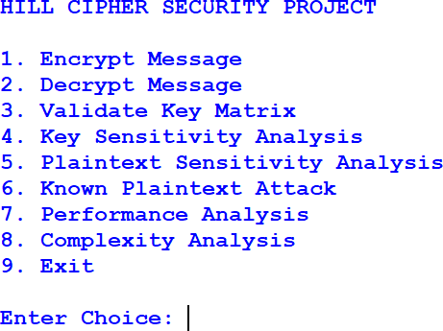

Encryption using 2x2 key matrix:
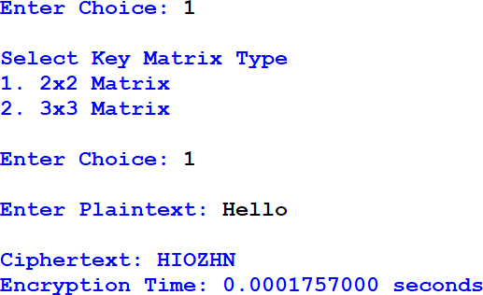

Encryption using 3x3 key matrix:
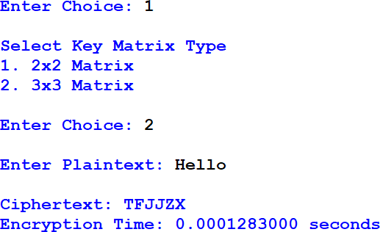

Decryption using 2x2 key matrix:
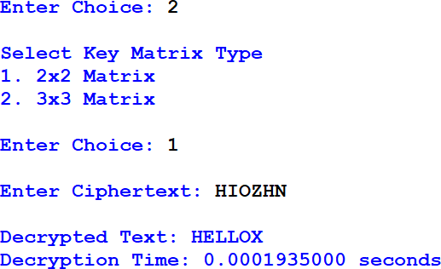

Decryption using 3x3 key matrix:
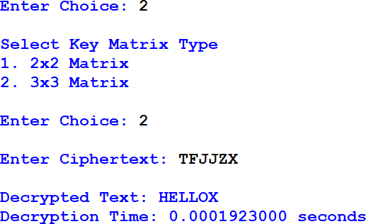

Key matrix validation (2x2):
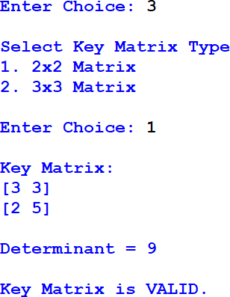

Key matrix validation (3x3):
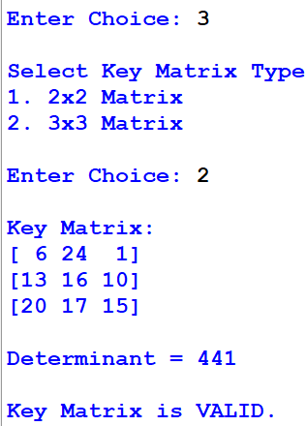

Key sensitivity analysis:
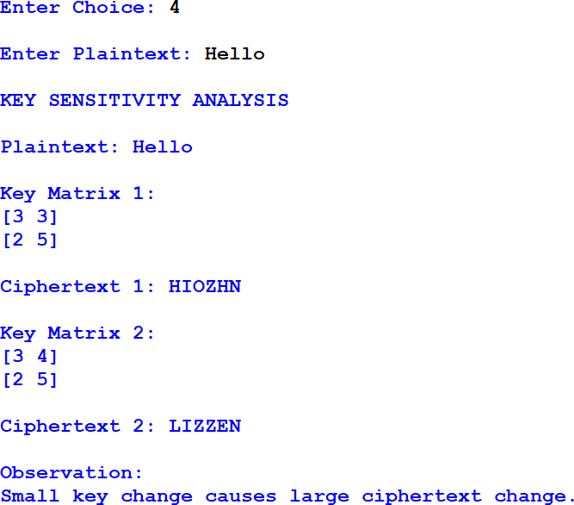

Plaintext sensitivity analysis:
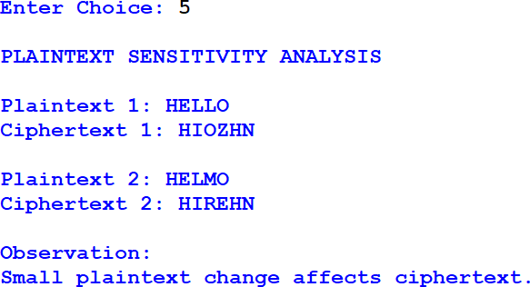

Known plaintext attack:
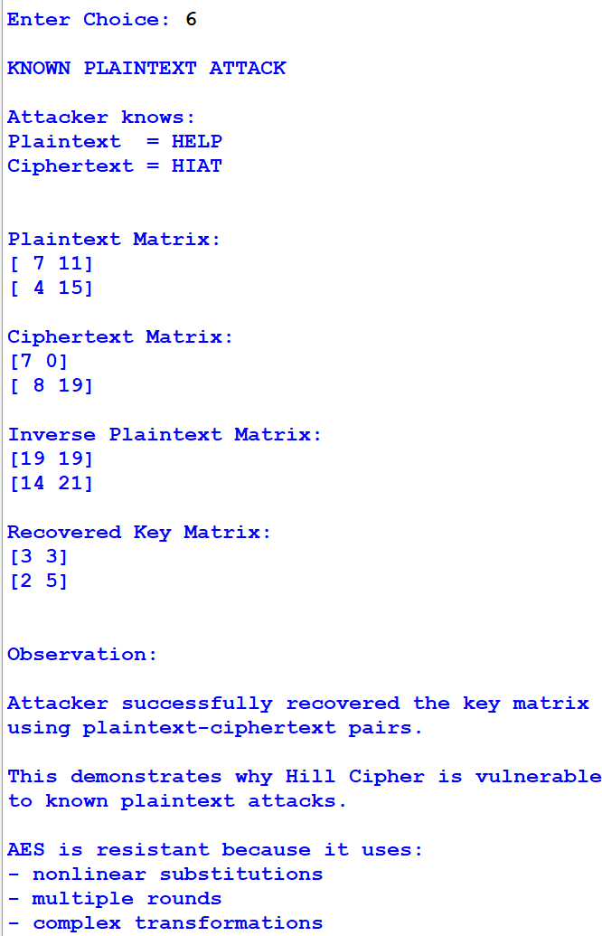

Performance analysis 2x2 key matrix:
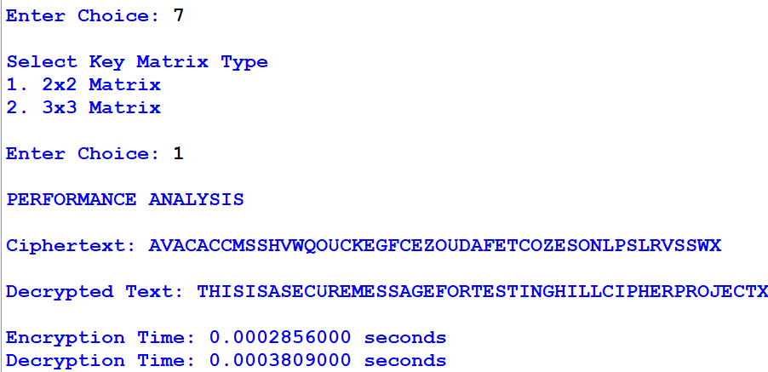

Performance analysis 3x3 key matrix:
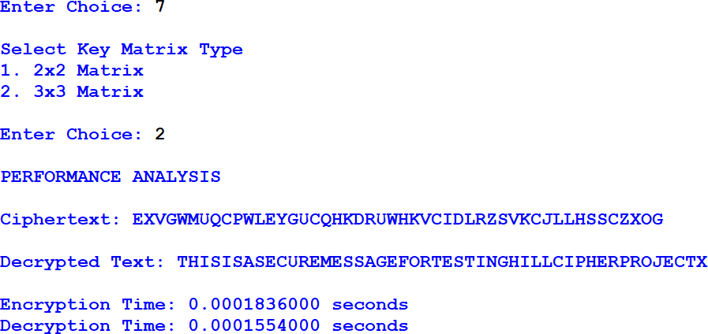

Complexity analysis:
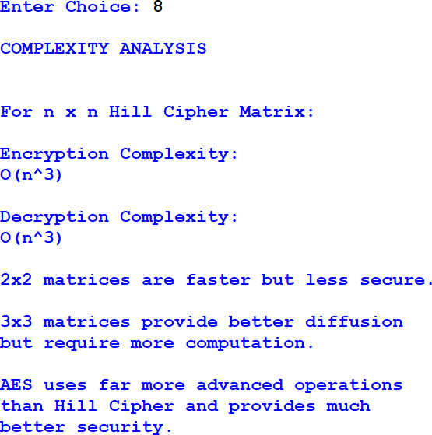

Conclusion
In this project, the Hill Cipher algorithm was implemented successfully for secure message encryption and decryption using Python. The project included both 2×2 and 3×3 key matrices along with key validation, encryption, decryption, sensitivity analysis, cryptanalysis, and performance analysis modules. The implementation helped in understanding how matrix multiplication and modular arithmetic are used in classical cryptography.
The results showed that small changes in the plaintext or key matrix create major differences in the ciphertext, demonstrating the diffusion property of the Hill Cipher. The project also showed the importance of invertible key matrices for proper decryption. Through the known-plaintext attack simulation, it was observed that the Hill Cipher is vulnerable because attackers can recover the key matrix using plaintext and ciphertext pairs.
Complexity and performance analysis helped compare the efficiency of different matrix sizes. Although the Hill Cipher provides better security than basic substitution ciphers, it is unsuitable for modern cybersecurity requirements due to its linear structure and vulnerability to attacks. Modern algorithms such as AES provide much stronger protection and resistance against cryptanalysis.
Overall, this project provided practical knowledge about encryption techniques, cryptanalysis, matrix operations, and modular arithmetic. It also gave a clear understanding of the strengths and limitations of classical cryptography in modern communication systems.

References

- CompTIA Security+ SY0-701 Certification Guide by Ian Neil, 3rd Edition, Packt publication.
- W. Stallings, Cryptography and Network Security: Principles and Practice, 8th ed.
- G. Strang, Introduction to Linear Algebra, 6th ed. Wellesley, MA, USA: Wellesley-Cambridge
- NumPy Documentation, NumPy Developers, “NumPy Documentation”
- B. Schneier, Applied Cryptography, 2nd ed., Wiley, 1996
- J. Daemen and V. Rijmen, The Design of Rijndael: AES-The Advanced Encryption Standard, Springer, 2002.

